ISLAMIC UNIVERSITY OF TECHNOLOGY

Organization of Islamic Cooperation

Board Bazar, Gazipur

Laboratory Report

CSE 4512

**Title**: Configuring numbered standard ACL in Cisco Devices

**Objective**:

* Plan an ACL Implementation
* Configure, Apply, and Verify a Standard ACL

**Devices/Software Used**: Cisco Packet Tracer

**Diagram of the experiment(s)**:

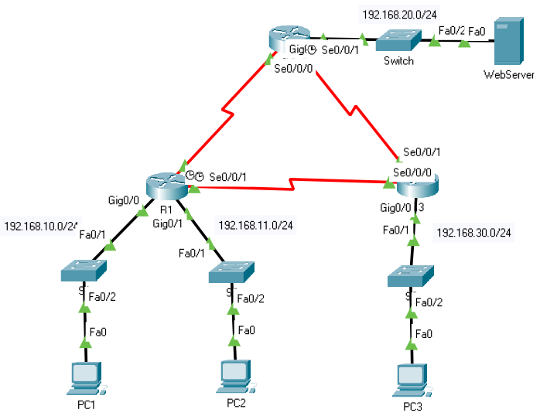

**Working Procedure**:

1. Verified that the network has full connectivity.

PC1 to PC2:

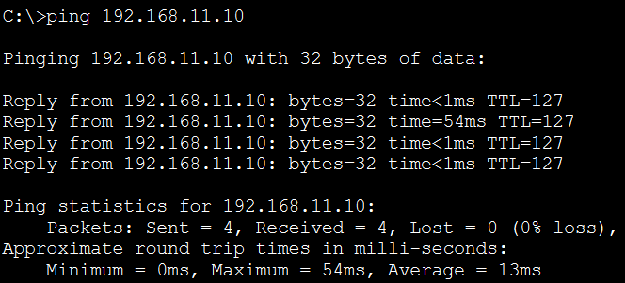

PC1 to PC3:

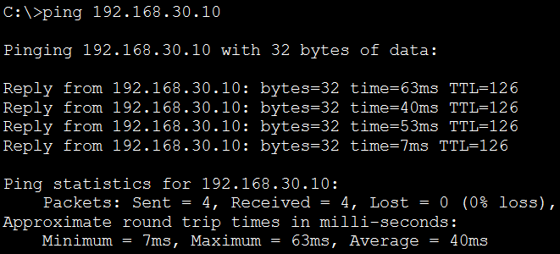

PC1 to WebServer:

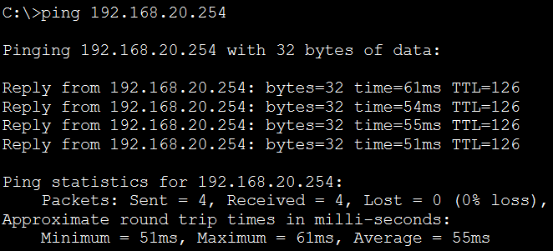

1. Evaluated and planned ACL implementations.
2. Configured and applied an ACL on R2.

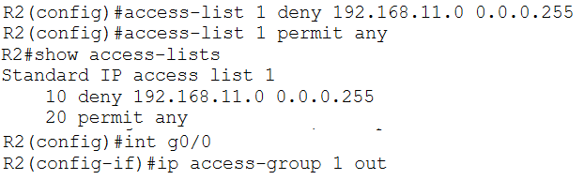

1. Configured and applied an ACL on R3.

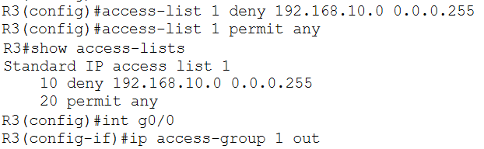

1. Verified ACL configuration and functionality.

On R2:

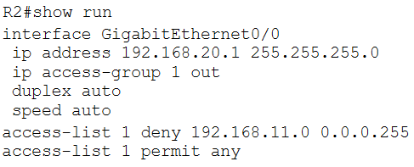

On R3:

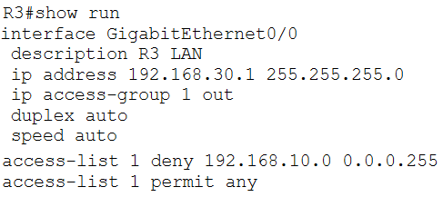

From PC1 to PC2:

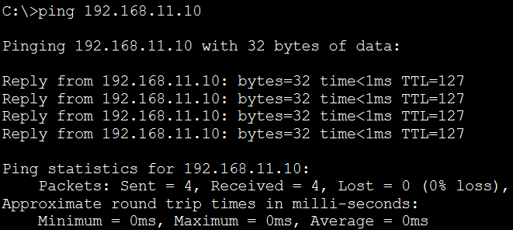

From PC1 to WebServer:

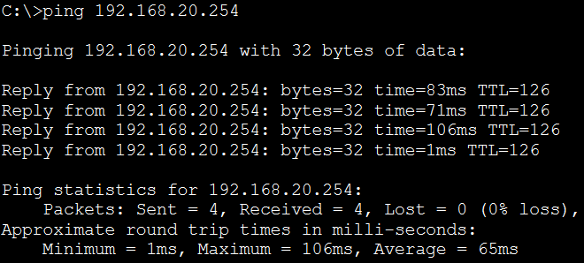

From PC2 to WebServer:

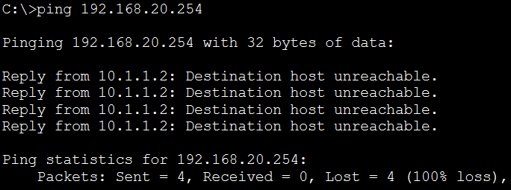

From PC1 to PC3:

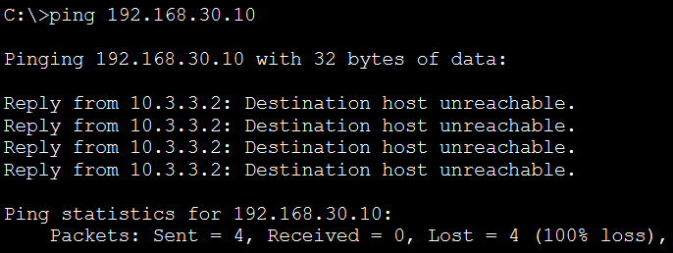

From PC2 to PC3:

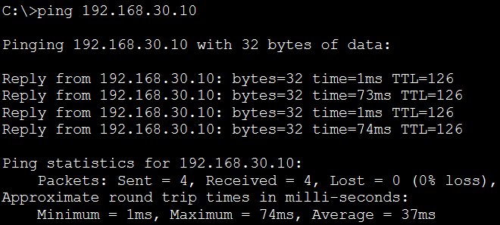

From PC3 to WebServer:

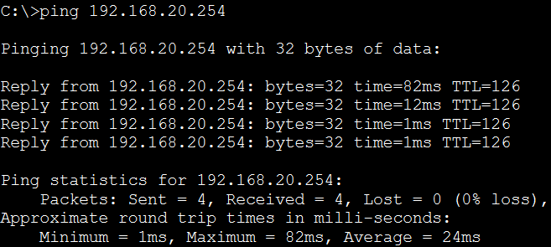

1. Issued the show access-lists commands again.

R2:

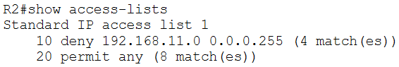

R3:

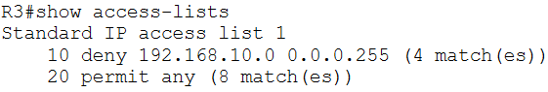

**Questions**:

Task # 01:

Question: The ping from 192.168.10.10 to 192.168.11.10 is successful or not?

Answer: Successful

Question: The ping from 192.168.10.10 to 192.168.20.254 is successful or not?

Answer: Successful

Question: The ping from 192.168.11.10 to 192.168.20.254 failed or not?

Answer: Failed